EXP. NO: 10PERFORMANCE ANALYSIS OF FM SYSTEM UNDER GAUSSIAN WHITE NOISE USING MATLAB
NAME:V.RUSHMITHA
DATE: 09/10/2026
Objectives
1. To generate a Frequency Modulated (FM) signal in MATLAB using the specified carrier and
message signal parameters.
2. To introduce Additive White Gaussian Noise (AWGN) into the generated FM signal and simulate
the effect of a noisy communication channel using MATLAB.
3. To analyze the effect of AWGN on the transmitted FM signal by comparing the original and noisy
FM signals using time-domain and frequency-domain analysis.
Procedure:
1. Open MATLAB and create a new script file.
2. Define the simulation parameters, including the sampling frequency, time vector,
message frequency, carrier frequency, message amplitude, carrier amplitude, frequency
deviation (or modulation index), and Signal-to-Noise Ratio (SNR).
3. Generate the message signal using a low-frequency sinusoidal waveform.
4. Generate the carrier signal using a high-frequency sinusoidal waveform.
5. Generate the Frequency Modulated (FM) signal by varying the instantaneous frequency
of the carrier according to the message signal.
6. Introduce Additive White Gaussian Noise (AWGN) into the FM signal using the
MATLAB awgn() function with the specified SNR value.
7. Perform FM demodulation on the noisy FM signal to recover the original message signal
using an appropriate MATLAB demodulation technique.
8. Plot the message signal, carrier signal, FM signal, FM signal with Gaussian White Noise,
and recovered message signal using MATLAB subplots.
PROGRAM (MATLAB CODE)
clc;
clear;
close all;
% Parameters
fs = 100000;
t = 0:1/fs:0.02;
fm = 500; % Message frequency
fc = 5000; % Carrier frequency
kf = 100; % Frequency sensitivity
% Message Signal
m = cos(2*pi*fm*t); c = cos(2*pi*fc*t);
% FM Modulation
fm_sig = cos(2*pi*fc*t + 2*pi*kf*cumsum(m)/fs);
% Add Gaussian White Noise
noisy = awgn(fm_sig,10,'measured'); % 10 dB SNR
% Display
figure;
subplot(4,1,1)
plot(t,m)
title('Message Signal')
grid on
subplot(4,1,2)
plot(t,m)
title('Carrier Signal')
grid on
subplot(4,1,3)
plot(t,fm_sig)
title('FM Signal')
grid on
subplot(4,1,4)
plot(t,noisy)
title('FM Signal with Gaussian White Noise')
grid on
OUTPUT (GRAPH)
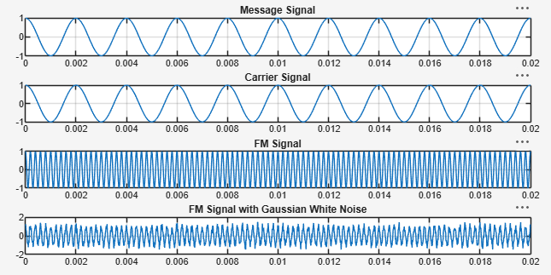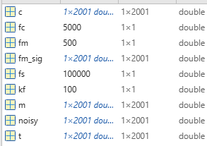
RESULT
1. Generated and visualized an FM signal using specified carrier and message signal parameters.
2. Introduced AWGN into the FM signal at a specified signal-to-noise ratio (SNR).
3. Compared clean and noisy FM signals in the time domain.
4. Computed the FFT and compare the frequency-domain characteristics of the clean and noisy FM signals.
5. Evaluated the influence of AWGN on the quality and spectral characteristics of the transmitted FM
signal.

